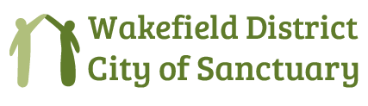
^{C}/_{O} 71 Howden Way Wakefield WF1 4PL
info@wdcos.org.uk Phone 07800605397
Registered Charity number: 1187477

Volunteer contact form (rev. 2023)

Wakefield District City of Sanctuary Mission Statement:
We take pride in welcoming Asylum Seekers and Refugees to our city and district and offer them every opportunity to share in and contribute to the life of our communities.
Wakefield District City of Sanctuary Mission Statement:
We take pride in welcoming Asylum Seekers and Refugees to our city and district and offer them every opportunity to share in and contribute to the life of our communities.

Aims:
To promote and encourage the inclusion of refugees and asylum seekers across the Wakefield District.

To inspire people to make Wakefield City and District a place of welcome, friendship and sanctuary.

To encourage and support local communities, voluntary groups, faith communities and organisations to welcome and assist asylum seekers and refugees.

To publicise and celebrate the contribution that asylum seekers and refuges make to our local communities, our society and culture.

To challenge hostilities and discrimination levelled against asylum seekers and refugees.

Volunteer Contact details:

Name …………………………………………………………. (Block Capitals)

Postal address:…………………………………………………………………………….

Preferred means of contact – phone…………………………………………………….
email ……………………………………………………..

Please state if you have a medical condition which we need to about:
……………………………………………………………………………………………….

In the event of an emergency who should we contact:

Name:………………………………………………………….

Phone:…………………………………………………………

Signed ………………………………………………………… Date:……………

